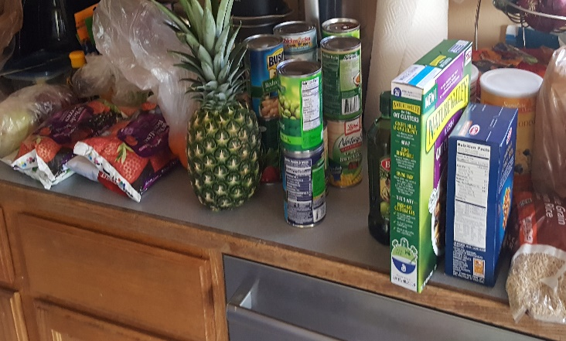
Cooking Healthy from a Pantry:

Easy Steps to Take to Have a Healthy Diet from Food Found in a Food Pantry

Chase Eastman, RDN, LD
Jake Yarberry, RDN, LD
Melissa Fleetwood, RDN, LD
Table of Contents:

1. Preface
2. Tips to Make Food Last!
3-4. Healthy Cooking Guide
5-9. Healthy Eating rules to Go By!
10. Cookware Guide
11-13. Cooking Language
14. Modify Your Meals!
15. Spice Guide

The Recipes
16. Whole Wheat Biscuits and Gravy
17. Overnight your Oats!
18. Whole Wheat Tortilla Pizza
19. Lean Pork Barbecue Skewers
20. Lean Beef Stuffed Bell Pepper
21. Chicken and Egg Fried Rice
22. Brown Sugar Salmon & Couscous
23. Beans, Veggies and Meat Chili
24. Turkey Meat Tacos
25. Toasted Cereal Bar

Preface
Cooking can be difficult. Cooking healthy can be even more difficult. Cooking healthy while only having access to foods from a food pantry can be extremely difficult. Who wants to even worry about health and nutrition when it’s hard enough to bring home food?
It is hard enough to be able to bring food home some days, let alone worry about whether the food will be healthy. For most, it is often a last concern, especially when hunger can cause bigger issues to one’s health. This simple cookbook exists with the purpose of giving you, the reader, the option to cook healthy, delicious meals, all from ingredients commonly found many food pantries. The worry about having poor health can be alleviated once done with this book, because it will show you different recipes that are great in taste and nutrition, but also has a breakdown of different food groups and their nutrients, why they’re needed in the body, and how often they should be consumed in the Healthy Eating Rules to Go By! section of this book.
Plus, to offer more variety, every recipe has the option to be customized with alternatives to add to make your dish more authentic! For instance: if you want Tex Mex options of flavor, just add cilantro (when available), corn, black beans, and tomatoes to any dish and Boom! You have yourself a new meal.
It is important to note that these recipes are made to be a healthy spin on what is commonly eaten. Turkey sausage won’t always be available, and that’s okay. We just want to show that healthy choices can be made.
So please, go ahead and enjoy this cookbook for what it is. It is jam-packed with credible information on nutrition and will give you the option to maybe one day make your own recipe from a food pantry!

Tips to Make Food Last!
There are tons of ways to make food that you receive from your local food pantry last longer. Sometimes making the food you receive stretch out until your next visit can be hard to do, but being able to find new ways to utilize what you have can be your best bet! Here are a few different ways that common food pantry items can be utilized in many ways. Creativity is key with all your food! Use these ideas to inspire new creations!
Rice is such a diverse grain! Rice can be served on its own, can be used to stuff a bell pepper with some ground meat and vegetables. Add rice as any side, or mix in with some leftover meats to create a complex, new dish!
Green Beans are one of the most diverse vegetables to cook with! Steam them, sauté them with olive oil, bake them with a protein, or mix them in with your favorite salad! Green beans are a tasty way to diversify your day!
Canned Chicken can be used in so many ways! Canned chicken can be put into a chicken salad-style sandwich, can be fried in a pan with an unsaturated oil with some vegetables, can be baked in a casserole, or can be thrown into a salad!

Another fantastic resource is through eatright.org. They provide free education for the public online, including an eating on a budget section.
Healthy Cooking Guide
Healthy eating, when it’s broken down, isn’t too hard to do. Culture and society plays a huge role in how food is cooked, and unfortunately the majority of culture cooks food in a not-so-healthy way! Here are some quick tips to make cooking a bit healthier.
- Try to avoid butter or bacon grease when cooking. Although it is rich in flavor, it adds unnecessary saturated fats to your diet, that are already in so many different foods out there. A saturated fat is any fat that is solid at room temperature, so if it’s a liquid oil, much like olive oil, it is unsaturated! Unsaturated oils are much easier for the body to utilize, and although your body does need some saturated fat, it is still best to avoid it when possible. If butter is all that is available for you, try reducing the amount you cook with!
- Portion out your meals. Although eating a lot at once is very common in American culture, it is also taxing on the body, and over time can lead to obesity. Being able to plan out your meals to have a fixed amount of food per meal, rather than going in all at once will save money and food (due to not eating as much at once), and will keep the food around a bit longer. Note: do not starve yourself. Portioning meals simply means to consume enough food until your stomach is satiated, or at a good level of full. Portioning out meals does not mean you’re starving yourself or stuffing yourself.
Healthy Cooking Guide
- Always try to have the low sodium option when available. Sodium is in literally everything, and your body does not need a lot of sodium throughout the day in order to be able to maintain proper functions in the body, so being able to cut out sodium when you can (choose low sodium broths and stocks, choose unsalted butter or low sodium cheese options) will help maintain a healthy lifestyle. If only regular options are available and there isn’t a low sodium alternative, make sure that when you use that product to not add any extra salt. This isn’t as ideal, but it will help lower sodium when possible.
- Watch out for heavy creams or hydrogenated oils. Heavy creams have a ton of saturated fat in them, and are in so many different ingredient lists. There are low-fat cream options that can do the same thing to a recipe! Hydrogenated oils are to be avoided whenever possible. A hydrogenated oil is a trans-fat, or a saturated fat that is even harder for the body to break down than a regular saturated fat. Eliminating these things from the diet will help give better options for a healthy lifestyle!
- Limit added sugars! Being able to limit the amount of added sugars in the diet will help in many ways, and prevent you from consuming excess calories without even knowing it!
Healthy Eating Rules to Go By!
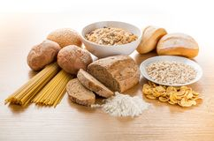
Grains: When people first try to eat healthy, they apply to their diet a certain stigma, or idea, that has been associated with cutting out grains, breads, and pastas from the diet to ascertain overall better health, but this is not necessarily the case. Healthy eating does involve eating grains if done correctly, and healthy grain options can be given at a food pantry from time to time! When choosing your grains, always try to look out for Whole Wheat or Whole Grain options. The recommendation is to make at least half of your grains Whole. This will give your body the carbohydrates it needs, plus, will give you plenty of fiber for good gut health! There are so many options out there to try with grains, such as quinoa, couscous, buckwheat, sesame, and many, many others. If you see a new one- try it, because you may end up really liking it.
Healthy Eating Rules to Go By!
Fruits and Vegetables: A food pantry can offer a wide variety of fruits and vegetables for you to bring to the table. This can include: fresh produce, chopped melons, canned fruits, pre-cut salads, pre-chopped vegetables (such as onions or sweet potatoes), and a variety of other mixes. Being able to diversify the nutrients in your diet is essential to maintaining good health. A great way to make sure you’re getting a variety of nutrients is to expand on the different colors of the food you eat, or taste all the flavors of the rainbow! If you eat red fruits one day, try a purple vegetable the next! This will give you plenty of healthy eating options year-round, without worrying about excess salts or sugar intake! Frozen fruits and veggies are also great!

Healthy Eating Rules to Go By!
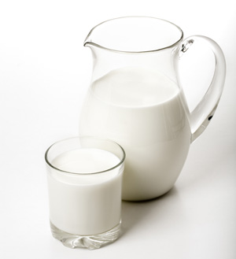
Milk Products, or Milk Alternatives: Milk is an excellent source of Vitamin D and Calcium, which are essential to good bone health as well as being a good source of protein. Milk and milk-derived products, such as cheese and butter, but did you know they can also be high in sodium and saturated fat? Having too much sodium or saturated fat in the diet can cause health issues, but choosing a low-fat option cheese or milk (such as cheese made with 1% or 2% milk, or 1%, fat-free, or even skim milk) can make milk and milk products much, much healthier! Waking up to a cup of low-sodium cottage cheese mixed with a cup of berries can start you off to a tasty beginning to your day. For those who may have a lactose intolerance or a milk allergy, there are plenty of other options that have comparable nutrient contents -including protein- as regular milk, and can be quite tasty! Soy options are out there, as well as many nut-brand milks (cashew milk, almond milk, and more), as well as lactose-free milk and lactose-free milk products! If you have any questions in regards to lactose content in a product, you can always look for the “lactose-free” stamp that will be on the container if it is lactose-free.
Healthy Eating Rules to Go By!
if you had ground beef the last time you were at the pantry, try grabbing a ground turkey meat the next if available! Not only is it a leaner protein, but you can make all the same foods with ground turkey that you can with ground beef!
Meats: Meats from a food pantry come in all shapes and sizes, and it is best to always try to embrace all the different possibilities that a food pantry can offer! Lean meats are going to be preferable options for your diet, but aren’t always available. When available, however, fish, chicken (white meat is lower in fat content), turkey, veal, and lean cuts of pork (pork tenderloin) and beef (flank steak, reduced fat ground beef) are healthier alternatives to meats such as bacon, sausage, high-fat ground beef (and yes, try to have reduced fat ground turkey as well!), and dark meat on chicken. Meats, typically deli meat, are often cured with salts for preservation practices and for flavor. Choosing a low sodium option is your best option for better health.
Fun Hint: If there are any white splotches in your meat, that is the saturated fat in what is called marbling. Marbling is meat that has fat mixed in with meat for better flavoring. Having a marbled meat may taste better, but is much higher in saturated fat content than a non-marbled meat option. Salami is one meat that is often marbled.

Healthy Eating Rules to Go By!
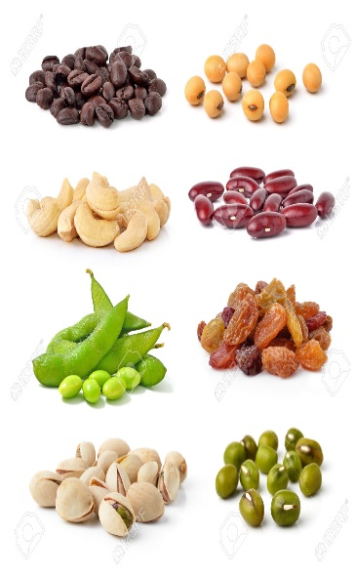
Beans, Nuts, Seeds & Legumes:
Beans are one of the best options that are typically always available in food pantries. Beans help provide essential nutrients that are essential, while being a great source of protein (vegetarians- these are for you!) and fiber, in which there are a ton of American people who are not eating enough fiber on a daily basis. Much like canned vegetables, beans can be high in sodium when in a can. Make sure to rinse them off to get rid of excess sodium!
Dried beans are easy to manage, too! All it takes is two steps:
- Soak beans overnight in large pot
- Boil beans until soft
Do these two steps and your beans will be ready for a variety of different possibilities to cook with.
Nuts, Seeds & Legumes are excellent sources of the fats that your body wants a lot of, as well as being a great source of protein. Nuts and legumes have what are called Monounsaturated Fats and Polyunsaturated Fats (or we’ll call them MUFA’s and PUFA’s) that are easier for your body to utilize and absorb, compared to saturated fats like butter. Nut butters, however, such as peanut butter and cashew butter are great ways to get good fats and protein, as well as Vitamin E in the body!
Cookware Guide: So many cookbooks out there have this over-ambiguous assumption of how everyone out there knows the difference between a sauce pan and a skillet. Here is a short picture guide to show what different kitchen items are out there!

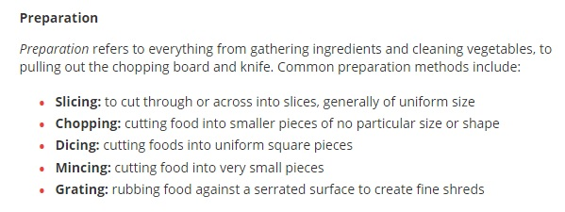
Cooking Language: Different terminology can be confusing to those who aren’t trained professionally in the art of cooking, which is most people! Yet, cookbooks still insist on using these confusing terms. This is a list, per eatright.org, that will hopefully clarify the different terminology that can be confusing!
http://www.eatright.org/resource/food/planning-and-prep/cooking-tips-and-trends/learn-the-language-cooking-vocabulary

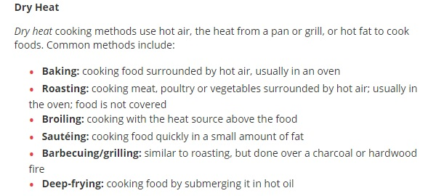
Cooking Language:
http://www.eatright.org/resource/food/planning-and-prep/cooking-tips-and-trends/learn-the-language-cooking-vocabulary

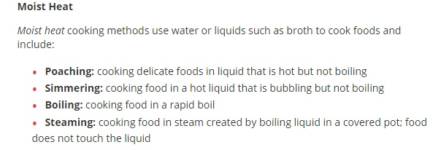
Cooking Language:
http://www.eatright.org/resource/food/planning-and-prep/cooking-tips-and-trends/learn-the-language-cooking-vocabulary

Modify Your Meal!
Even with limited access to food, there is still the potential to be your own personal chef! Any and all of the meals options in this book have the ability to be played around with, to create totally new dishes! Provided is a list of different ingredient ideas that help promote different meal options for what’s in this book.
Tex Mex: Add corn, cilantro, tomato, and black beans to any dish, along with some cumin if available!
Southern Style Kick: With any protein option, add a side of red beans and rice, along with a slice of toasted whole wheat bread or a biscuit to give it a southern flair! Also, try adding Cheyenne powder if available!
Greek: Swap out bread for a whole-wheat pita bread if available, add olives, feta cheese (or any other white cheese that you can crumble up yourself), slice red onions, and add olive oil and a vinaigrette.
Italian: Add low-sodium tomatoes or low-sodium tomato paste to create a sauce, along with garlic powder, oregano, and parsley flakes.

Spice Guide:
Utilize your flavors the way you want! If you’re craving one of these recipes but always want to taste diversity, try one of these alternate flavors!

- Mediterranean and Italian: Basil, oregano, red onion, olives, thyme.
- South and Central Americas: Cilantro, red onion, jalapeño, lime juice.
- Western Europe, French: Tarragon, capers, Dijon mustard, shallots.
- Indian: Coriander, ginger, sultanas (like a raisin), clove, chilies, garlic.
- Asian: Cilantro or Thai basil, ginger, garlic, scallion, orange, rice wine, fish sauce, soy sauce, sesame oil.

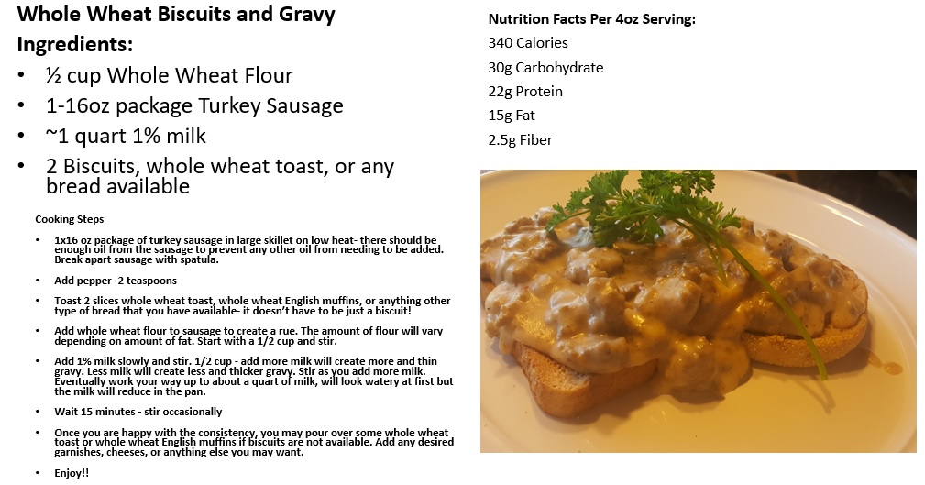
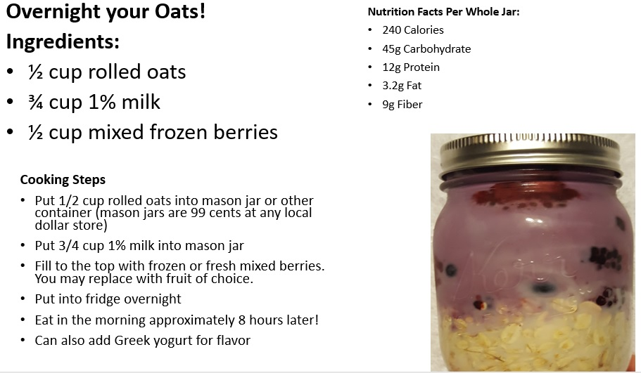
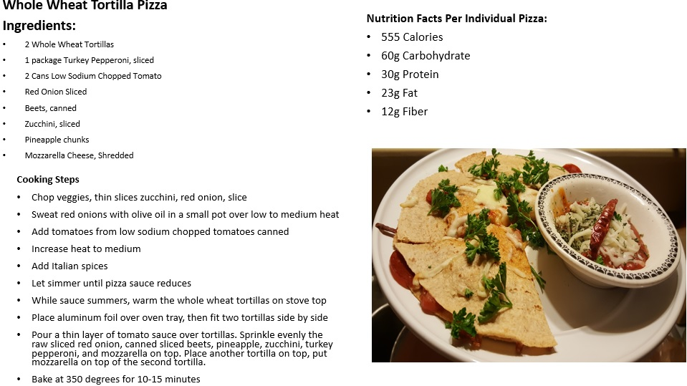
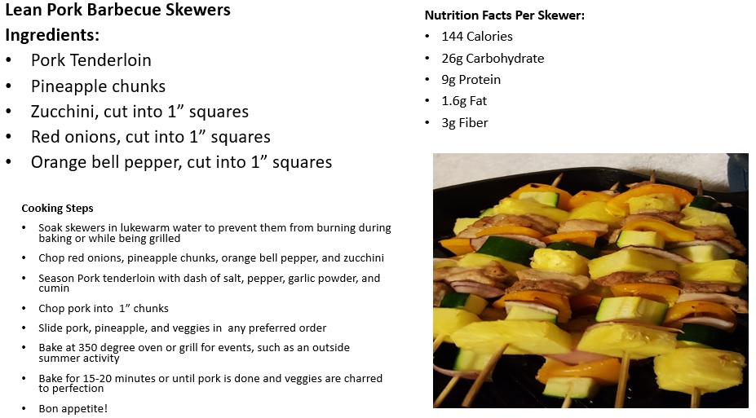
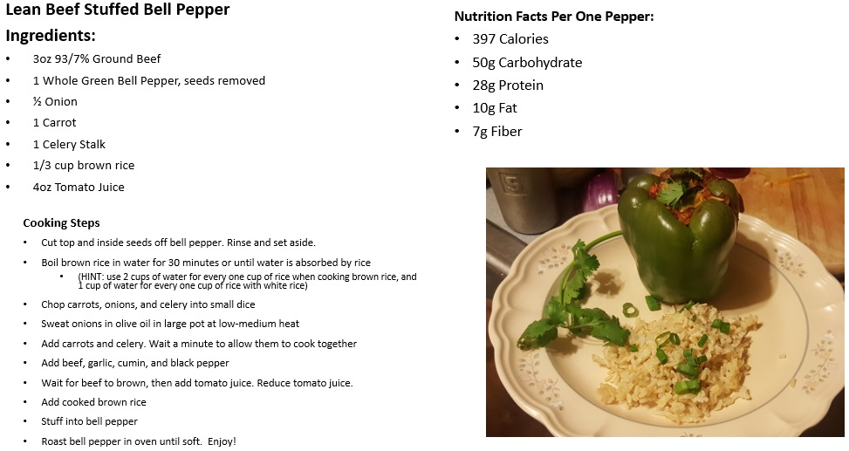
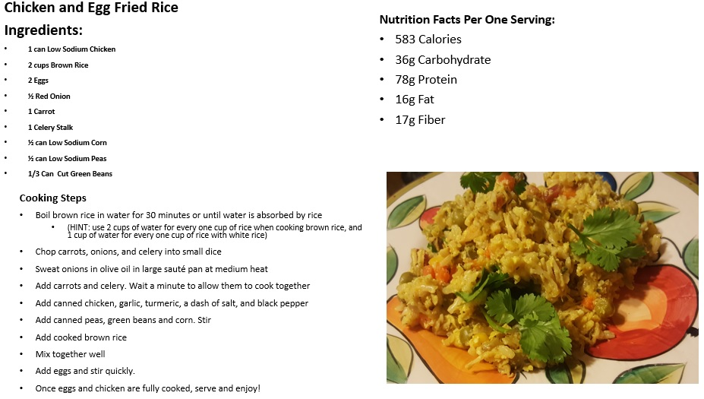
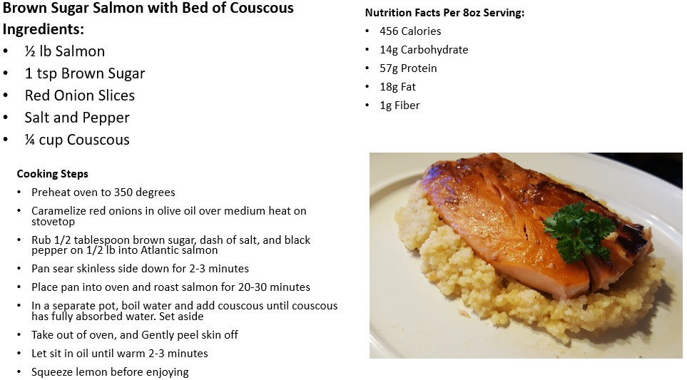
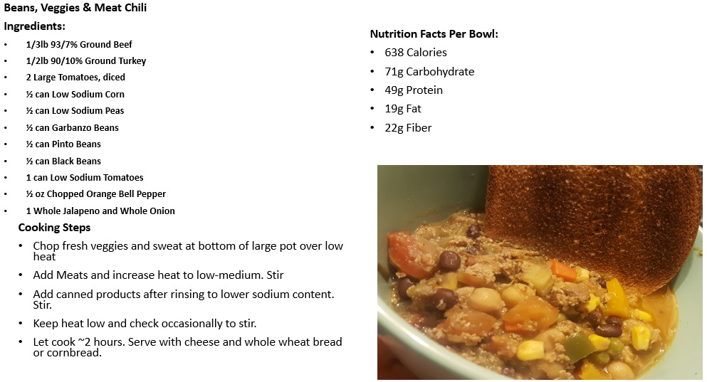
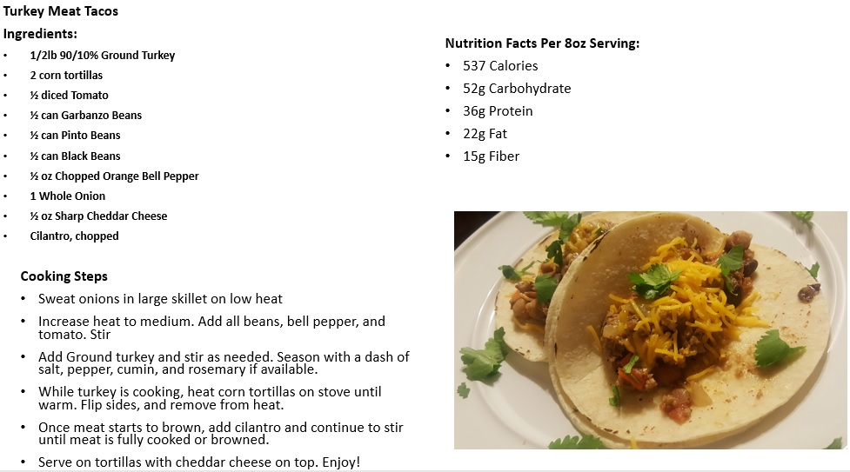
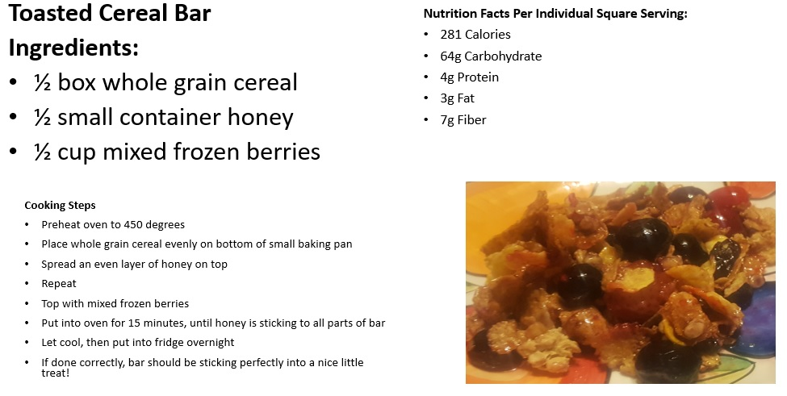
Sources:
http://www.eatright.org/resource/food/nutrition/dietary-guidelines-and-myplate/choose-whole-grains
http://www.eatright.org/~/media/eatright%20files/nationalnutritionmonth/handoutsandtipsheets/nutritiontipsheets/20waystoenjoymorefruitsandvegetables.ashx
http://www.eatright.org/~/media/eatright%20files/nationalnutritionmonth/handoutsandtipsheets/nutritiontipsheets/eatrightwithmyplate.ashx
https://www.eatrightpro.org/~/media/eatrightpro%20files/career/career%20development/flyers%20and%20handouts/ernt_everyday_eating_for_a_healthier_you.ashx
https://www.usda.gov/media/blog/2014/05/15/beef-your-knowledge-meat-marbling-101
http://www.eatright.org/resource/health/wellness/preventing-illness/protect-your-health-with-immune-boosting-nutrition
https://www.choosemyplate.gov/budget-recipes
http://www.eatright.org/resource/food/nutrition/nutrition-facts-and-food-labels/the-basics-of-the-nutrition-facts-panel
http://www.mealime.com/kitchen-essentials-list
http://www.eatright.org/resource/food/planning-and-prep/cooking-tips-and-trends/learn-the-language-cooking-vocabulary
Drummond, K. E., & Brefere, L. M. (2016). Nutrition for Foodservice and Culinary Professionals (9th ed.). Wiley Inc. doi: 1119271770, 9781119271772
https://www.supertracker.usda.gov/

